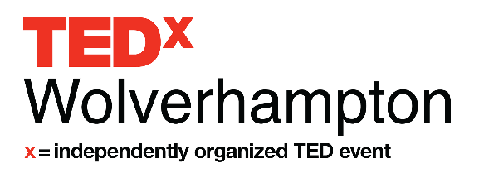
Speaker Application Form

Name

First Last

Phone

Email

Website (optional)

Facebook URL (optional)

Twitter URL (optional)

Are you applying to be a speaker, performer or group performance?

□ Speaker
□ Performer
□ Group Performer

Have you spoken at any other TED or TEDx event?

□ Yes
□ No

What life and career experiences will inform your TEDx talk? (Research, education, work experience, life story.) (100 words)

Tell us about your topic. (300 words)

The theme of TEDxWolverhampton 2021 is ‘Ctrl Alt Del’. We will be exploring ‘control’ within society, ‘alternative ways’ of thinking and ideas, approaches and concepts that have been or need ‘deleting’ to enable us and our communities to grow and thrive.
At TEDxWolverhampton 2021 we’re exploring ideas that challenge, turn long held and accepted norms on their heads, challenge the status quo and reset and reboot our thinking
Our theme is open to interpretation and can be applied in a number of ways.

How will your talk relate to our theme? (250 words)

How does your big idea relate to this year’s theme "What's Next?" (250 words)*

What are the talking points of your presentation? (500 words)

Have you spoken on a public stage before?

□ Yes
□ No

Please provide a link to a video of you speaking/performing. If you don’t already have
such a video, please make a 2minute demo video, upload it to YouTube and provide us the link. We are interested in your style and passion for your topic over the quality of your video. (link and up to 50 words)

TEDxWolverhampton is dedicated to you. Because we require each speaker to talk for no more than 12 minutes, our TEDx Team will be available for coaching and refining your idea to make it the best we can for you while on stage. With this is mind we will be organising coaching and audition sessions closer to the event.

Please provide a picture and biography that can be used for the program. Attach the files as two separate documents. Accepted file types: jpg, gif, png, pdf.
Please attach any further documents, (CV, research paper) you feel will aid us in understanding you or your topic better. Accepted file types: jpg, gif, png, pdf.

By submitting this application, and checking the box below, you understand that participating in TEDxWolverhampton as a speaker is unpaid, although reasonable expenses will be reimbursed.

Applicants selected to speak will have a video produced and disseminated through international and national media channels.

□ I agree
□ Yes, please add me to your Speaker Applicant e-mail list

Please return your completed application to info@TedXwolverhampton.com by Midnight on Sunday 16th May 2021.

