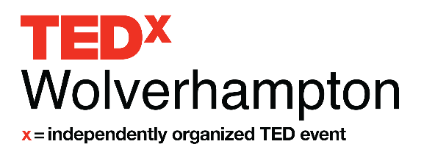
Speaker Application Form
About TEDx, x = independently organized event
In the spirit of ideas worth spreading, TEDx is a program of local, self-organized events that bring people together to share a TED-like experience. At a TEDx event, TED Talks video and live speakers combine to spark deep discussion and connection. These local, self-organized events are branded TEDx, where x = independently organized TED event. The TED Conference provides general guidance for the TEDx program, but individual TEDx events are self-organized. (Subject to certain rules and regulations.)

We are seeking speakers who have an idea worth spreading! A TEDx Talk presents great, well-formed ideas in under 18 minutes. We understand and appreciate that you may have a hugely motivating life story, but if it doesn’t fit with the spirit of ideas worth spreading, we won’t be able to shortlist your application. Similarly, all ideas must be based in sound science, avoiding political agenda and religious proselytizing!

Please complete in BLOCK CAPITALS

Name

Phone

Email

Website (optional)

Facebook URL (optional)

Twitter URL (optional)

Are you applying to be a speaker, performer or group performance?

Speaker
Performer
Group Performer

Have you spoken at any other TED or TEDx event?

Yes
No

What life and career experiences will inform your TEDx talk? (Research, education, work experience, life story.) (100 words)

Tell us about your topic. (300 words)

The theme of TEDxWolverhampton 2020 is Ctrl+Alt+Del where we’ll be exploring 'control' within society, 'alternative ways' of thinking and ideas, approaches and concepts that have been or need ‘deleting’ to enable us and our communities to grow. Ctrl+Alt+Del, is the commonly known combination of keys on a PC keyboard, used to re-boot the system. This year, at TEDxWolverhampton 2020 we seek ideas that challenge, turn long held and accepted norms on their heads, challenge the status quo and reset and reboot our thinking!

How will your talk relate to our theme? (250 words)

How does your big idea relate to this year’s theme "What's Next?" (250 words)*

What are the talking points of your presentation? Remember we’re seeking ideas worth sharing! (500 words)

Have you spoken on a public stage before?

Yes
No

Please provide a link to a video of you speaking/performing. If you don’t already have
such a video, please make a 2minute demo video, upload it to YouTube and provide us the link. We are interested in your style and passion for your topic over the quality of your video. (link and up to 50 words)

TEDxWolverhampton is dedicated to you. Because we require each speaker to talk for no more than 12 minutes, our TEDx Team will be available for coaching and refining your idea to make it the best we can for you while on stage. With this is mind we will be organising coaching and audition sessions closer to the event.

Please provide a picture and biography that can be used for the program. Attach the files as two separate documents. Accepted file types: jpg, gif, png, pdf.
Please attach any further documents, (CV, research paper) you feel will aid us in understanding you or your topic better. Accepted file types: jpg, gif, png, pdf.

By submitting this application, and checking the box below, you understand that participating in TEDxWolverhampton as a speaker is unpaid, although reasonable expenses will be reimbursed.

Applicants selected to speak will have a video produced and disseminated through international and national media channels.

I agree
Yes, please add me to your Speaker Applicant e-mail list

Please return your completed application to info@TedXwolverhampton.com by 5pm on Friday 10th January 2020.

