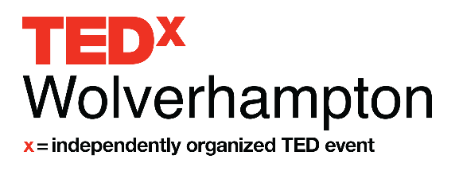
Speaker Application Form

Name

First Last

Phone

Email

Website (optional)

Facebook URL (optional)

Twitter URL (optional)

Are you applying to be a speaker, performer or group performance?

Speaker
Performer
Group Performer

Have you spoken at any other TED or TEDx event?

Yes
No

What life and career experiences will inform your TEDx talk? (Research, education, work experience, life story.) (100 words)

Tell us about your topic. (300 words)

The theme of TEDxWolverhampton is ‘Mind the Gap – Building Bridges’. We seek to explore the gaps that exist within our society and within our knowledge, understanding and relationships as a human race. Our theme is open to interpretation and can be applied in a number of ways.

How will your talk relate to our theme? (250 words)

How does your big idea relate to this year’s theme "What's Next?" (250 words)*

What are the talking points of your presentation? (500 words)

Have you spoken on a public stage before?

Yes
No

Please provide a link to a video of you speaking/performing. If you don’t already have
such a video, please make a 2minute demo video, upload it to YouTube and provide us the link. We are interested in your style and passion for your topic over the quality of your video. (link and up to 50 words)

TEDxWolverhampton is dedicated to you. Because we require each speaker to talk for no more than 12 minutes, our TEDx Team will be available for coaching and refining your idea to make it the best we can for you while on stage.

Please let us know your availability to attend a meeting in Wolverhampton to discuss. We will also be available by phone and video call.

Date 1
Date 2
Date 3
Date 4

Please provide a picture and biography that can be used for the program. Attach the files as two separate documents. Accepted file types: jpg, gif, png, pdf.
Please attach any further documents, (CV, research paper) you feel will aid us in understanding you or your topic better. Accepted file types: jpg, gif, png, pdf.

By submitting this application, and checking the box below, you understand that participating in TEDxWolverhampton as a speaker is unpaid, although reasonable expenses will be reimbursed.

Applicants selected to speak will have a video produced and disseminated through international and national media channels.

I agree
Yes, please add me to your Speaker Applicant e-mail list

